This script is designed to be pasted into Powershell ISE for you to then copy the file path, run the script then paste it into the text box.

Here you can see the printers i have access to. Some Group policies stop devices from being able to connect to printers on the print server. There is a manual way to add them via the gpedit command in the terminal
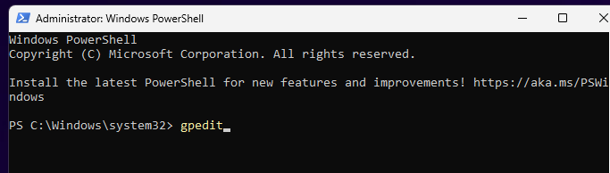
Once you hit enter ( and your terminal is open in admin) you’ll have this window pop open
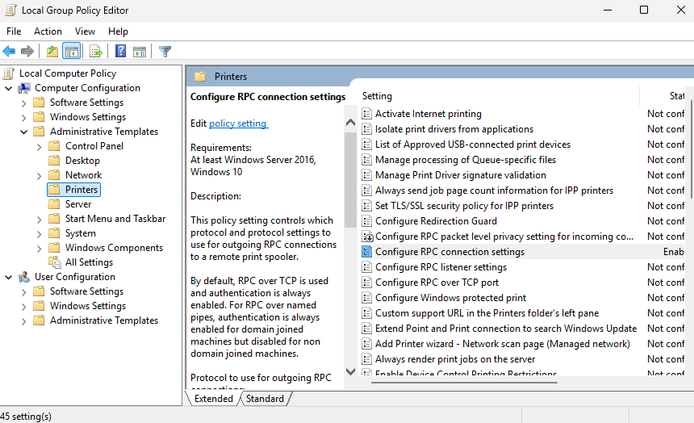
Select Configure RPC connection Settings
This window will then open
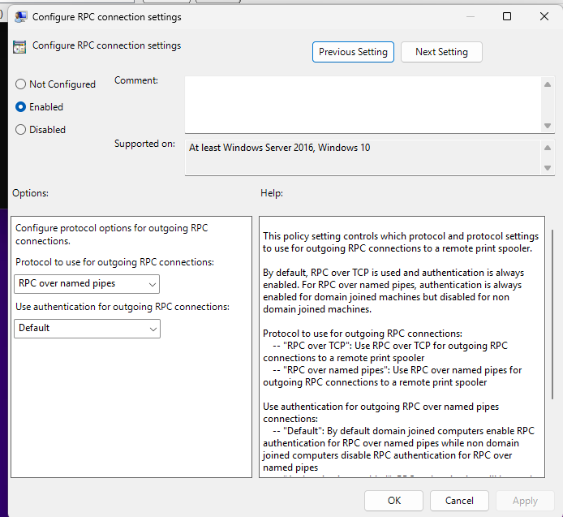
As long as RPC over named pipes is applied you can use the print server

HOWEVER this has been automated

Please open the script in this Doc folder called Add_printer_remotely_script.ps1
It first enables RPC connections over named pipes, but it will also enable you to add a printer by pasting the file path into the script. You can then push the script out in NinjaOne or you can save it on a usb stick and run it on each device that needs it.

First copy the script into powershell ISE on the script (not the terminal) side or the white side
Run it and it will stop at this line…
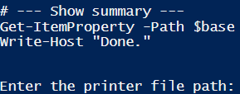
…and it will wait for you to enter the file path for the printer

Here’s how to do it:

go to \\adsprint-prd-1 in the file explorer
Find your printer
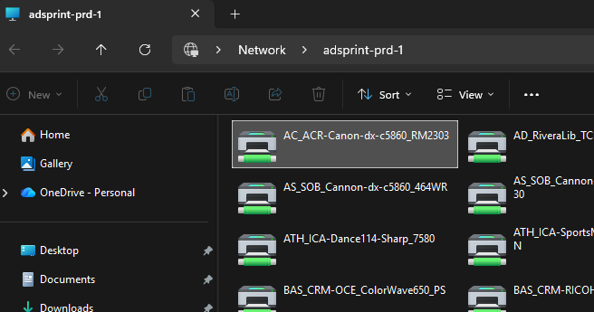
Click and drag it to the desktop
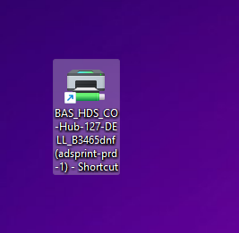
Right click and select properties
Select the text in the target field
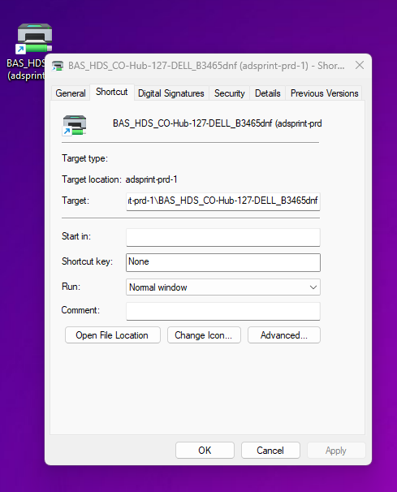

Ctrl + a to select all and copy via crtl + c
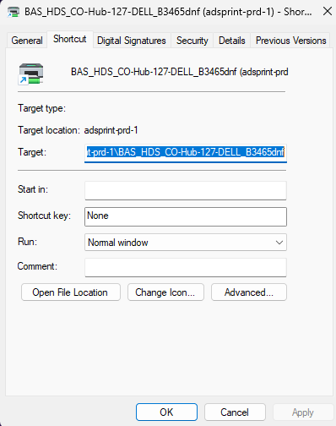
Then paste it into the script
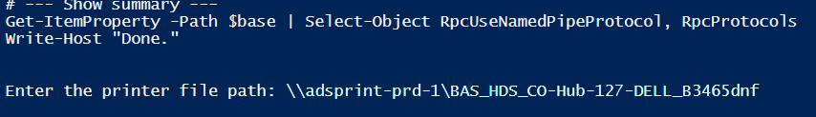
Hit enter
Let the script run until here:
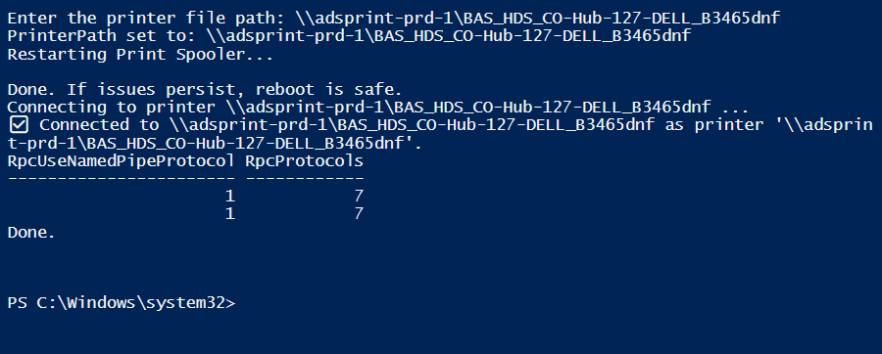
The script will then show all connected printers
Done
